Logo here

Your full website checkup report

Which contains :-

- Browser compatibility test
- SEO test
- Responsive test
- Whole Website HTML validation

Browser compatibility test

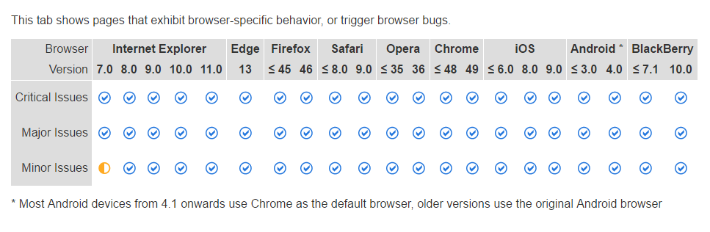
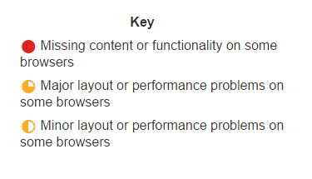

The above chart indicates that your website is compatible with all the websites in all given version. Which makes it clear that your website has passed the browser compatiblity test .

Seo test

Title tag is well and fine in your website it contains 52 characters.
Website Design and Development | SEO Company Kolkata

Make sure your title tag is explicit and contains your most important keyword.
Please note that every page has a unique title tag

